MILITARY ORDER OF THE COOTIE
Honor Degree of the Veterans of Foreign Wars of the United States

SUPREME COMMANDER
Emil A. Soltesz

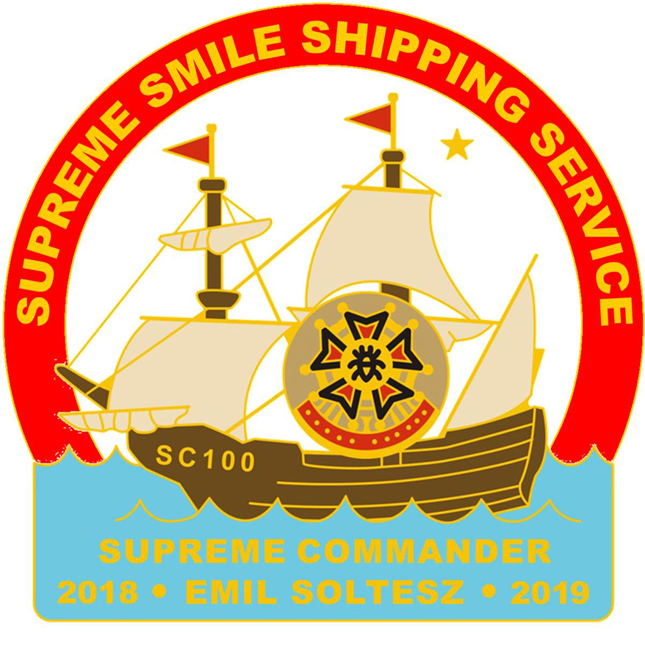

“VETERANS ARE VIP’s”

PROGRAM BOOK
2018-2019

Table of Contents
Supreme Commander’s message.......................................................................................pg. 3

Supreme Info.....................................................................................................................pg. 4

Supreme President’s message and Info.............................................................................pg. 5
Supreme Policy..............................................................................................................pg. 6-7

98th Supreme Scratch.......................................................................................................pg. 7

84th Trek to the Tomb of the Unknowns..........................................................................pg. 8

Grand of Michigan VFW National Home Cootie Christmas Party..................................pg. 9

Grand of Ohio Easter Treat Program................................................................................pg. 9
Cootie Courier..................................................................................................................pg. 10

Supreme Chief-of-Staff Program.....................................................................................pg. 11

Chaplain of the Year Program.........................................................................................pg. 12

Supreme Cootie of the Year Program..............................................................................pg. 12

Supreme Special Appointments.......................................................................................pg. 13
Supreme Membership Program.................................................................................pg. 13-14

Supreme Life Membership Program...............................................................................pg. 14

Supreme Hospital Program........................................................................................pg. 15-17

Supreme Clown Program................................................................................................pg. 18

Supreme Inspection Program..........................................................................................pg. 19

Supreme All-Star Program..............................................................................................pg. 20

Supreme Blood Program.................................................................................................pg. 21
Supreme VFW National Home and Special Projects......................................................pg. 21

Supreme VAVS Program.................................................................................................pg. 22

Grand of Pacific Areas Paddy Daddy Programn...................................................................pg. 23

Pennsylvania Keystone Kops Program............................................................................pg. 24

Texas Horny Toad Program.............................................................................................pg. 24
Blue Guard Program.......................................................................................................pg. 25

Blue Angel Program........................................................................................................pg. 26

Oregon Trail Program.....................................................................................................pg. 27

Michigan NitPickers Program.........................................................................................pg. 28

MOC Hospitalier Knights Program.................................................................................pg. 29

Maryland VFW National Home Honorary Fire Department..........................................pg. 30
Past Supreme Commanders.............................................................................................pg. 31

SCHEDULE OF EVENTS 2018 - 2019.............................................................................pg. 32

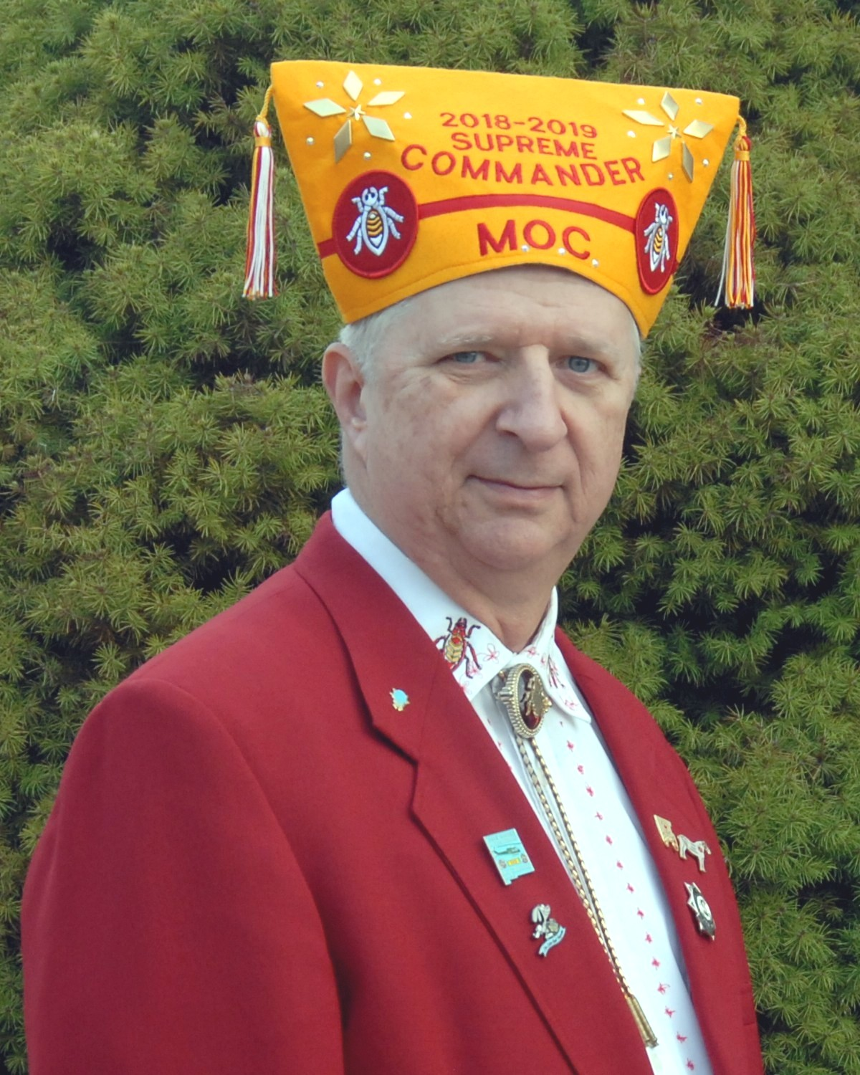

SUPREME COMMANDERS MESSAGE
Listen Up Cooties,

We are all in this together. Having been elected to the office of Supreme Jr. Vice Commander in 2016 in my first message I closed with, “What makes this organization so great is not its leadership; it is each person doing what they can and working together…” Now as Supreme Commander, I can move forward knowing all too well that we will have a great year because each cootie will continue to do what they can and work together. Every cootie is important to the success of the Military Order of the Cootie. Can there be a few that may go astray? Sure; however, from the VFW Ritual “CEREMONIAL INITIATION - Junior Vice Commander: …When the breath of scandal touches the character of a comrade…” Some great advice follows this opening line cooties: to paraphrase, we should always strive to be closer than a brother.

We are also blessed with an Auxiliary that will be there with us, just as we should be there for them. Some believe the Auxiliary in not that important to the organization; therefore, some have both feet planted firmly in mid air. The auxiliary represents a large group of the best there is and should be treasured for their work and dedication within and for our organization.

We must keep in mind the VFW is our parent organization and we need to keep their best interest in mind. Remember your obligation to our Country, the United States of America; we took an oath to her that still stands today. Above all else family first, this is a fundamental principal of the VFW and MOC.

It is an incredible honor to serve as your Supreme Commander this year. The cooties elected and appointed, and all the other cooties at all levels of the Military Order of the Cootie represent a force that “Keep 'em Smilin' in Beds of White.” So let’s have some fun and remember SMILE: it makes people wonder what you’re up to. It also makes for better pictures.

My motto: “Every Cootie’s a VIP” to your family, the VFW, the MOC and the MOCA.

L.O.T.C.S.

Emil A. Soltesz
Supreme Commander 2018 - 2019

MOC Information

Supreme Commander  Emil Soltesz  6152 Stratford Dr.  Parma Heights, OH 44130  Phone: (440) 885-2955  Email: esoltesz@ameritech.net  Senior Vice Commander  Steve Ruger  448 Chancy Rd  Waycross, GA 31503  Phone: 912-550-8763  Email: steverugersr@gmail.com | Supreme Quartermaster  Gary Dressel  Supreme MOC Headquarters  604 Braddock Avenue  Turtle Creek, PA 15145-2086  Phone: (412) 824-2240  Email: supremehqmoc@lotcs.org  Supreme Adjutant Jesse Kitson  399 Lincoln Ave  Cliffside Park, NJ 07010  Phone: (302) 745-8651  Email: mocgrandofdeqm@gmail.com

SUPREME PRESIDENTS MESSAGE

Congratulations to Supreme Commander Emil, the officers & chairmen of the Military Order of the Cootie. Please know you have the full support of the Military Order of the Cootie Auxiliary in all your endeavors. We are honored to walk beside you through this year.

I am so humble yet proud to be serving as Supreme President for our great organization, the Military Order of the Cootie Auxiliary. Thank you everyone for the love and support you have each shown me on my journey to reach this great position.

Together the MOC and MOCA will reach out to the Veterans and Military personnel to always reassure them we have not forgotten them. They are the very reason we do with love what we do.

Loyally,

Patricia A. Potter
2018-2019 Supreme President

“Veterans Are The Stars”

MOCA Information

Supreme President  Pat Potter  2633 West Adams  St. Charles, MO 63301  Phone: (314) 420-3756  Email: ppotter1293@gmail.com  Senior Vice President  Marquitta Hill  P. O. Box 1461  Tupelo, MS 38802  Phone: (601) 596-7546  E-mail: Nicolevfw@yahoo.com | Supreme Treasurer  Penney Howard  P.O. Box 34  Flora Vista, NM 87415  Phone: (505) 330-1023  Email: moca-supreme-treas@comcast.net  Supreme Secretary  Georg Jean Zimmerman  304 Hilltop Ln.  Chestertown, MD 21620  Phone: (443) 480-5656  Email: gzimmerman@atlanticbb.com
SUPREME POLICY 2018-2019

1. The Supreme Commander shall be responsible for the command and direction of the Supreme Scratch and all matters of policy not stated herein shall be subject to the discretion of the Supreme Commander. All authorized travelers; please use prudent judgment in minimizing travel expenses. Total amount of the budgeted allowance for each officer will remain available to the officer during the fiscal year. Each officer can request part of their allowance with proper receipts during the coming fiscal year.

2. The Supreme Commander and the Supreme Quartermaster will conduct all balloting in question through the office of the Supreme Adjutant. Responses will be tallied by an independent source. Results will be mailed, faxed, or e-mailed to the Supreme Council members.

3. Council of Administration Members are expected to attend all Council meetings. If you are going to be absent, you should notify the Supreme Adjutant who will notify the Supreme Commander. Council members must file a detailed annual report not to exceed one 8.5” x 11” page. This report should be filed with Supreme Headquarters before the 100th Supreme Scratch (unless provided for in the Supreme By-Laws).

4. The Supreme Council of Administration shall approve the Supreme operations and maintenance budget at the first Council meeting following the Supreme Scratch.

5. The Annual Budget: The Supreme Quartermaster will manage Supreme Headquarters and the Headquarters staff subject to the direction of the Supreme Commander.

6. The Supreme Council of Administration shall approve the Supreme Quartermaster and Supreme Adjutant allowance for his term of office. The Supreme Quartermaster shall be given due consideration for travel funds for any official travel authorized by the Supreme Commander.

7. Any Proposed Changes to the approved Supreme Budget must be referred to the Budget Advisors for recommendations to the Supreme Council of Administration prior to the Council’s actions.

8. The Supreme Commander will prepare travel vouchers and submit them to Supreme Headquarters with supporting documentation for payment of travel expenses.

9. Travel Allowance Reimbursement for the Supreme Senior Vice Commander, Supreme Junior Vice Commander, and Supreme Chaplain will be paid immediately upon submission of a properly completed and authorized travel voucher, not to exceed their budgeted allowance. Any specified assignment given to a Supreme officer having a budget allowance will have their reimbursement taken for that Command-Directed trip from the officer Travel account. All other Cooties/officers assigned by the Supreme Commander to travel will report their expenses in detail upon completion of their assignment. They will submit a full report of activities, properly filled out travel voucher and supporting documentation within one week following their trip. Non-reimbursable expenses are those expenses paid by a third party or expenses deemed inappropriate by the Supreme Commander.

10. Official Travel Reimbursement: Lodging will be at the single room rate except when the traveler is sharing a room and then the reimbursement will be at the shared rate. Transportation will be reimbursed at the most economical airfare rate for advanced reservations, not to exceed coach airfare or POV mileage at 32 cents per mile, 3125 miles maximum. Ground transportation will be reimbursed at both ends (i.e. home- airport-hotel-airport-home). Rental car, if more advantageous, will be reimbursed if pre-approved by the Supreme Commander. In no case will any reimbursable assignment exceed the amount per assignment as approved within the Supreme Budget.

11. The Supreme Commander is responsible for assigning Supreme representatives to the Grand Scratches. Transportation will be reimbursed to the officer in accordance with established policy (see #10 above). Exceptions must be pre-approved by the Supreme Commander. Grand Pup Tents are expected to provide housing and official function tickets. If a specific Supreme representative is requested for an event other than a grand Scratch, the Grand involved is expected to arrange with the requested individual about expenses. The Supreme Commander has the ultimate authority in all assignments.

12. A Replacement Fee of $6.00 offsets any cost for the replacement of all Life membership cards that are lost, destroyed or stolen.

13. A Supreme Officer or representative will inspect all Grand’s unless waived by the Supreme Commander. The inspection of the Grand is not calculated in that Grand’s requirement to be 100% inspected.

14. All Goals are formulated using the 31 May 2018 end-of-year membership report. All Supreme programs will end 31 May 2019.

15. Each Cootie will be assessed $2.00, $1.00 for the Supreme Commanders Special Project and $1.00 for the annual maintenance fee MOC/MOCA House at the VFW National Home.

16. Supreme Headquarters will mail a 100th Supreme Scratch packet to any registered delegate or Pup Tent unable to pick one up on site at Orlando, FL if the delegate of a Pup Tent requests it. That includes any Pup Tent complying with Section 534 of the By-Laws of the Supreme Pup Tent dated 30 July 2017. The Supreme Quartermaster/Adjutant’s office will see that all registrants not in attendance, and if a request is made from same, receive their packet by mail no later than 30 September 2018. Supreme Headquarters and the current Budget Chairman will ensure that funds are available for registrants of a Supreme Scratch/Convention not in attendance, to receive a convention packet, if they so request, by mail no later than 30 days after the close of the Supreme Scratch or while supplies last.

17. All Supreme Officers on Command-Directed assignments are required to attend all functions for the event that they are attending, (i.e. Grand Scratch, Memorial Services, Council Meetings, Banquets, Installations, Past Grand Commander’s Meeting, if eligible and qualified, etc.). Non-attendance at these functions will be subject to disciplinary action and reimbursements will be declared ineligible.

18. Although any member in good standing can run for any Supreme Office, the preferred sequence for Supreme Jr. Vice is:

2018-19 – Pacific area (AK, AZ, CA, CO, HI, ID, MT, NM, NV, OR, PAC, UT, WA, WY)
2019-20 – Central Area (AL, AR, IA, KS, LA, MN, MS, MO, OK, NE, ND, SD, TN, TX)
2020-21 – Northern Area (CT, IL, IN, KY, MA, ME, MI, NH, NJ, NY, OH, RI, VT, WI)
2021-22 – Atlantic Area (DC, DE, EUR, FL, GA, MD, NC, PA, SC, VA, WV)

19. The Official Third-Degree Password for 2018-19 is:

51-3 25-39-29-31-31 41-29-19-3

100th SUPREME SCRATCH
The 100th Supreme Scratch will be held in Orlando, FL 24 - 28 July 2019. Each Pup Tent is required to pre-register at least one delegate to the Supreme Scratch. An advance registration fee of $15.00 is due 15 days before the Supreme Scratch. The advance registration form and additional information will be in upcoming editions of the Cootie Courier and on the Cootie website LOTCS.org. Properly filled out registration forms with proper fees must be received by the Supreme Registration Chairman not later than 15 July 2019. All registrants, whose monies and forms are received after 15 July 2019, will owe $20.00. (Save $5.00 by getting yours in before the deadline.) Start making plans to attend the 100th Supreme Scratch and VFW National Convention now.

100th Supreme Convention Chair Cootie
Gary Dressel

84th TOMB TREK 2018
ARLINGTON NATIONAL CEMETERY

This year the Trek to the Argonne Cross and Tomb of the Unknowns will be held on 2 - 4 November 2018.

HOTEL INFORMATION: Sheraton Hotel, 900 Orme St, Arlington, Virginia, 22204, Room rates $109.00 plus tax. Parking is $ 10.00 per day. You may reserve your room online at: https://www.starwoodmeeting.com/events/start.action?id=1703311581&key=13E6B9B2
or Contact Hotel directly at (703) 521-1900 for reservations. Mention the Military Order of the Cootie for proper rate. Cutoff Date for room block reservations is 1 October 2018.

OTHER INFORMATION: WREATH REGISTRATION $25.00

ADVANCED REGISTRATION:
Full Registration = $85.00, Banquet = $ 50.00, Bus Ticket = $15.00, Registration Only = $20.00

AFTER 1 OCTOBER 2018:
Full Registration = $100.00, Banquet = $55.00, Bus Ticket = $20.00, Registration Only = $25.00

Forms for Registration and Wreaths will be found on the lotcs.org website, under the Events tab and will be in the Cootie Courier. Make Checks payable to “Tomb Trek Committee” and send them with completed forms to: Jane Channell, 2728 Hillside Court, Ijamsville, MD 21754-8806

MOC DRESS REQUIREMENTS: Red Blazer, White Shirt, Cootie Bolo or Red Tie, White Pants (With or Without Red stripe) Red Socks, White Shoes, Proper Cootie Cover and White Gloves.

MOCA DRESS REQUIREMENTS: White Skirt (or pants) with the appropriate stocking, Red Blazer, White Closed Shoes and Cover.

REMEMBER THAT ONLY COOTIES AND AUXILIARY CONFORMING TO THE FORMAL DRESS REQUIREMENTS WILL BE PERMITTED TO PRESENT A WREATH. THERE ARE NO EXCEPTIONS TO THIS POLICY.

Mark Newman, Tomb Trek Chairman, 348 David Hall Road, Dover, Delaware 19904, Tele: 302-222-7558, email: mnewman122@gmail.com

90th GRAND OF MICHIGAN MOC VFW NATIONAL HOME COOTIE CHRISTMAS PARTY December 1, 2018

Every year, the Grand of Michigan is the host and sponsor of the “Cootie Christmas Party” for the
children of the VFW National Home. Your donations are necessary for this program to work and we
need your HELP!
Make your checks payable to: MOC Grand of Michigan, and send to Ernest A. Paulin, Grand of Michigan Quartermaster, 710 Aldrich Street, Linden, MI 48451-9050. Earmark your checks as to how you wish your donation to be dedicated exclusively;
If you wish to HELP in the purchasing the gift cards for the children – Earmark “Cootie Christmas Gift Cards”.

If you wish to HELP with the Shuttle Bus cost – Earmark “Cootie Christmas Shuttle Bus”.
If you wish to HELP with the Hospitality room beverage and snack cost – Earmark “Cootie Christmas Hospitality”.
If you wish to HELP with the Cootie Christmas Lunch – Make your checks payable to: MOC Grand of Florida, and send to Steve Surface, Grand of Florida Quartermaster, 12460 91st Way N., Largo, FL 33773. Earmark “Cootie Christmas Lunch”.
The host hotel is Quality Suites Hotel, 901 Commerce Drive off West Saginaw Street in Lansing,
MI 48917. CALL (517)886-0600 or 1-800-456-6431 for reservations. Room rates are $92.00/night.
Be sure to say it is for the Military Order of the Cootie! CALL Banquet Coordinator Naida Schelter
at (517)626-6942 for reservations and send a check for $40 per person, made out to “MOCA

Capitol City #5” and mail to Naida Schelter (email: anaida6488@aol.com), 9750 Riverside Dr.

Grand Ledge, MI 48837. DON’T DELAY. PGC Eric Bell is the MOC Chairman.

36th Grand of Ohio Easter Treat Program

Each year, the Grand of Ohio is host to the Children of the VFW National Home. Upcoming will be the
36th Annual Cootie Easter Treat and all are invited to participate. Mark your calendar for the dates 12-14 April 2019 continuing success for this Easter Program for the children depends on how good your hearts are and how open your wallets are. Please send your contributions early so we can buy the necessary supplies to ensure the kids have the biggest and best Easter ever. The VFW National Home opens their doors each year for the Cooties of Ohio to host this gala event for the children of the National Home and we need your help and support to continue the great event. Donations can be made out to Grand of Ohio, and Sent to Grand Quartermaster, Chuck Cihlar, 489 Monroe Blvd., Painesville, Ohio 44077, Telephone
440-358-1148. You may email your request so please place in the subject line of the email
"MOC SUPREME EASTER TREAT". Your donations will not go unrecognized.

SCHEDULE OF EVENTS: (Dates subject to change.)

*Friday 12 April 2019 • Arrival of personnel and set up of baskets for delivery on Saturday. Dinner with
Ohio House residents

*Saturday 13 April 2019 • Final Basket Preparations. Meet the Easter Bunny and basket presentation in the Community Center, Ice cream social, Easter Egg Hunt at the gym, then off to Jackson for Roller Skating.

*Sunday 14 April 2019 • Attend Church with the Children from the National Home and then on our way to our own homes. This is a long weekend of fun and frolic with the kids from the National Home, and the only program where you get to actually interact with the kids for the whole weekend. What a great experience. Thank you in advance for your help and support for the program.

COOTIE COURIER

RECEIVING THE COOTIE COURIER: We encourage all Cooties to get the Cootie Courier delivered
via electronic mail. Postage is increasing and the bulk mail is getting slower. If you elect to get your paper via electronic mail, send your request and e-mail to vfwwebmaster@gmail.com. If you want the Courier delivered by mail it will cost you $10.00. Send your check to Supreme Headquarters.

HOW TO SUBMIT NEWS COPY
The Cootie Courier; just like all other papers, is looking for current and interesting news that will be interesting to all our readers. Remember that space is always a consideration and most times limited, so please keep articles direct and to the point.

BASIC RULES FOR ALL SUBMISSIONS:
1. Try to have each article contain the five W’s — who, what, when, where, why, and oftentimes, how. With "who" use the correct ride, and of important note — insure that all names are spelled correctly!
2. You can send your articles to the Cootie Courier Editor by email (preferred method) at vfwwebmaster@gmail.com.
3. Photos submitted via e-mail MUST be in a JPEG (.jpg) file.
4. Other ways of submission are land mail to:
Dale Iannello
1013 74th St E Apt C Tacoma, WA 98404

5. DO NOT SUBMIT ITEMS FOR THE COOTIE COURIER TO SUPREME HEADQUARTERS. That just delays the time the article is received by the Editor.
6. PHOTOS: Strive to use a solid light colored background. Remember that your submitted pictures will not be printed on Kodak photo paper! Remember that this is our Cootie newspaper, so try to have the photos depict Cooties doing MOC/MOCA activities.
7. When submitting your annual election bio sketch, you should ALWAYS include a photo.
8. If you move please submit a change of address. The form is located elsewhere in this publication and
available through our website www.lotcs.org. If you change your email address please forward your new one to the editor as well. The editor may edit a submitted story to fit the paper.

SUPREME CHIEF-OF-STAFF PROGRAM
2018-2019

OBJECTIVE: The objective of the Supreme Chief-of-Staff Program is to strengthen the ranks of the Military Order of the Cootie through Pup Tent growth, Pup Tent reinstatement, and working closely with our parent organization, the Veterans of Foreign Wars of the United States, in all areas especially in the area of VFW recruitment.
GUIDELINES: All Chief-of-Staff, Membership Chairmen, and all Cooties will take responsibility for the success of this Program. The following Guidelines are provided for all Cooties:
1. Promote our VFW Honor Degree by encouraging all VFW workers to read Article XII of the VFW
By-Laws and Manual of Procedure Sections.
2. Promote our VFW Honor Degree by presenting to all VFW workers who seek the Seams of any
Pup Tent our MOC Invitation Brochure.
3. Report at all VFW Post Meetings and VFW District Meetings what our VFW Honor Degree has done in the name of our VFW.
4. Recruit as many VFW workers as possible into the ranks of our Military Order.
5. Help Pup Tents in need to ensure they are conducting our VFW Honor Degree Business and
Programs properly. It is much easier to rebuild a Pup Tent Membership than to organize a new Pup
Tent. Always EXTEND a helping hand and NEVER give up.
6. Grand Chiefs-of-Staff will become familiar with the MOC Pup Tent starter kit. The Starter Kit can be requested through Supreme Headquarters or at www.lotcs.org under the Forms tab. The Starter Kit is a great management tool and all information contained within should be shared with all Pup Tents and Cooties.
REPORTING: Report the increase of all NEW/RE-INSTATED Pup Tents to the Supreme Chief-of-Staff. The Chief-of-Staff Program deadline is 31 May 2019. All reports are due by 01 June 2018.
Calculating New/Reinstates Pup Tents: The Grand must first deduct all declared defunct Pup Tents
during the same Program Year to attain the net increase.

SUPREME CHIEF-OF-STAFF PROGRAM AWARDS:
1. Any Cootie organizing a NEW Pup Tent will be awarded Supreme Deputy Chief-of-Staff and will receive a Supreme Citation.
2. Any Cootie rebuilding a Pup Tent will be awarded Supreme Deputy Chief of Staff and will receive a
Supreme Citation.
3. The Grand Chief-of-Staff reporting the most NEW or REINSTATED Pup Tents in each Division will receive a Supreme Citation. Categories will be for first, second, and third place in each Division.
4. The Grand reporting the most NEW and REINSTATED Pup Tents for the current Program Year will receive the Don Bird Traveling Gold Gavel Award for one year. Any Grand winning this trophy three consecutive years will keep the award permanently. Let's recruit as many MOC members as possible.

Supreme Chief of Staff
Joseph McCullough, PSC, 107 Ranch Country Dr, LaVernia, TX 78121, Ph. 210-818-4583
Email: mcculljt@hotmail.com

CHAPLAIN OF THE YEAR PROGRAM
2018-2019
OBJECTIVE: The Supreme Commander desires that special recognition be given to outstanding Sky Pilots and Chaplains in the Military Order of the Cootie.

MISSION: The Sky Pilots and Chaplains in the MOC are second to none. Their labor of love brings true credit to the MOC and its Programs. The Supreme Sky Pilot or Chaplain of the Year Program is an excellent opportunity to recognize your best Sky Pilot or Chaplain. Sky Pilots of the Pup Tent, Chaplains of the Grand, District or Area, have been recognized at the Supreme Scratch each year as Supreme Sky Pilot of the year or Chaplain of the Year since Cootie Year 1975-1976.

SELECTION:
1. Selection of the Supreme Sky Pilot of the Year or Chaplain of the Year is done from letters of
nominations sent by Pup Tent Seam Squirrels, Grand District and Area Commanders, Grand Commanders,
and Supreme Council members to the Supreme Chaplain.

2. Letters of nomination are judged by a Select Committee of no less than three people who are NOT
members of the MOC or VFW, but who understand fully the work or labor of the Chaplain. Any Sky Pilot
and Chaplain previously selected as Sky Pilot of the Year or Chaplain of the Year on any level is not eligible
for recognition a second time at that level. However, if they are honored at one level, they can be honored at another.

3. Nomination letters should be written on MOC letterhead.

4. Letters postmarked after 15 May 2019 will not be considered. Nomination letters may be mailed between
1 June 2018 and 15 May 2019.

5. Letters of nomination should contain facts, not just words. We have Sky Pilots and Chaplains who do
great work in this, and our parent, organizations. So please nominate them and get them recognized by sending your letter to the Supreme Chaplain.

6. Do not let your Sky Pilot or Chaplain down. Please make a nomination for this honor. If you don’t
nominate them, they cannot be recognized.

Allan T. Perkins, Supreme Chaplain, 4715 Cashel Castel Dr., Houston, TX. 77069.
Telephone 281-450-7825 email: atp1991@sbcglobal.net

SUPREME COOTIE OF THE YEAR PROGRAM
2018-2019
I know there are numerous Species Pediculi in our Grands that are constantly working the seams, keeping them smiling and being closer than a brother. If you know of such a lousy Cootie that you would like to submit to be considered for the award "Cootie of the Year", please send me a detailed description of what this Cootie has performed to:
Mark M. Newman, PSC 13-14
348 David Hall Road
Dover, DE 19904-5463
Email: mnewman122@gmail.com, Phone: 302-222-7558
If you have any questions, please contact me. If you can't get your nomination to me thru the above means, then bring it to the Supreme Convention and give it to me or any Past Supreme Commander. We know there must be some deserving Cooties out there, so let us know and provide us with the opportunity to make a selection. The Cootie that is selected will then be presented the Award during Supreme Convention Banquet.

SUPREME SPECIAL APPOINTMENTS
2018-2019
OBJECTIVE: The Supreme Commander desires that special recognition be given to outstanding
Cooties with Supreme Special appointments.

NOMINATIONS: Grand Commanders and Seam Squirrels from the Black Division may submit nominations beginning 31 July 2018, for your deserving Cooties for Supreme Special appointments. Please nominate your outstanding Cooties early for these appointments so they can proudly wear their new tassels. NOTE: Tassels are not provided for these appointments. Appointees receive certificates and credential cards only. Tassels must be purchased separately at a cost of $5.00/pair through the Supreme Supply Department. You can send nominations in or hand-carry them in as early as 9:00 am on 31 July 2018, at the new Council of Administration in Kansas City, MO.

APPOINTMENTS: The following are appointments that are available for nomination:
Supreme Deputy Chief-of-Staff
Supreme Deputy Inspector
Supreme Recruiter (VFW or MOC)
Supreme Seam Worker
Supreme Cootie Supporter
Supreme Aide-de-Camp
Supreme Newshound
Supreme Comedian
Supreme Cheerleader
Supreme Cootie Juicer

SUPREME MEMBERSHIP PROGRAM 2018-2019

The objective of the Supreme MOC Membership Program is to encourage all Pup Tents to SURPASS their 31 May, 2018 membership total by recruiting at least one (1) New member. The Supreme organization recognizes all Grand’s and Pup Tents who reach their goal.
COMMANDER’S MESSAGE: That we do our duty as any SPECIES PEDICULI to INCREASE and MULTIPLY; this is our goal for 2018-2019. We have a tremendous pool for membership. There are workers of the Veterans of Foreign Wars who wish to become a Cootie; all you have to do is ask them. Do your duty and these good comrades will join our ranks and you will become an active species.
QUARTERMASTERS and CCDBs: Membership transmittals must be postmarked by 31 May
2019. Look at the awards Program below and set your goals.
RECRUITING AWARDS: Cooties recruiting five (5) or more new members into a Pup Tent or Grand as verified by the Grand Membership Chairman will receive a Supreme Bronze Recruiting pin. Any Cootie recruiting ten (10) or more new members into a Pup Tent or Grand, as verified by the Grand Membership Chairman, will receive a Silver Recruiting pin. Any Cootie recruiting 15 or more new members into a Pup Tent or Grand will receive a Gold Recruiting pin and be appointed Supreme aide-de-camp, recruiting Class and will receive a Supreme Commander’s lapel pin and citation.
PUP TENT AWARDS: Pup Tents with 100% paid membership PLUS a growth factor of two (2) new or reinstated members by 31 December 2018 and verified by Supreme Headquarters, will receive a Supreme Commander’s Pin, and a Supreme Citation. Pup Tents with 100% paid membership by 31
May 2019 will receive a Supreme Citation.

SEAM SQUIRRELS AND CCDB’s: Seam Squirrels and CCDBs with 100% paid membership PLUS a growth factor of two (2) new or reinstated members by 30 November 2018 and verified by Supreme Headquarters, will receive an “Outstanding SS” and “Outstanding CCDB” pin, and a Supreme Citation. The Seam Squirrel’s name will be entered into a drawing to win one of the following for the 100th Supreme Convention: 1.) A three day stay; 2.) A two day stay and a banquet ticket; 3.) A one day stay and a banquet ticket. This is only for the Seam Squirrel and is not transferrable and is only for the room and does not include food or transportation costs. Transmittals must be postmarked by 30 November 2018. Pup Tents with 100% paid membership by the end of the 2018-2019 year (31 May 2019) will receive a Supreme Citation.
GRAND AWARDS: Grand’s that are 100% in membership by 31 December 2018 will have their Grand Commanders name entered into a drawing to win one of the following for the 100th Supreme Convention: 1.) A three day stay; 2.) A two day stay and a banquet ticket; 3.) A one day stay and a banquet ticket. This is only for the Grand Commander and is not transferrable and is only for the room and does not include food or transportation costs. Transmittals must be postmarked by 31 December 2018. Grand’s with 100% paid membership by the end of the membership year 31 May 2019 will receive a Supreme Citation.
COMPUTING YOUR BASE MEMBERSHIP: Computing the quota for each Pup Tent will be as follows: Total membership as of 31 May 2018, total membership is the total of continuous members, plus life members, plus those members that did not renew (pay) their membership for the current year or the prior year, plus one (1) new or reinstated member. Any deceased members reported during the membership must be made up. For a Pup Tent to be 100% in membership it must grow by one (1) new or reinstated member. Delinquent members will fall off the roster in the 3rd year after they did not pay their membership dues. The Supreme Quartermaster’s records will be used to compute and membership awards.
Grand Quartermaster’s are directed to forward a copy of the Grand membership transmittals to the Supreme Membership Chairman.

Ralph Corno, Supreme Membership Chairman, 41 Brookville Rd, Edison, NJ 08817 Telephone: 732-406-9233, Email vfw5@aol.com

SUPREME LIFE MEMBERSHIP PROGRAM 2018-2019
The Life Membership Program has been approved and is in effect. First, all applicants must be VFW Life members –NO EXCEPTIONS. Second, all applications for Life Membership must be paid-up continuous 3rd Degree members for the current year. The Life Membership dues are as follows:
If you are…..
Through age 30 - $340.00;
31 through 40 - $325.00;
41 through 50 - $305.00;
51 through 60 - $275.00;
61 through 70 - $245.00
71 through 80 - $190.00;
81 and over - $150.00

SUPREME HOSPITAL PROGRAM
2018-2019

OBJECTIVE: It is the objective of the MOC Hospital Program to encourage all MOC members to actively participate in hospital visitations and volunteer work. A goal of $250.00 credit per Cootie
has been established for the 2018-2019 program year.

SUPREME COMMISSIONER/HEADQUARTERS LEVEL PROGRAM
1. The Supreme Commander shall appoint the SUPREME HOSPITAL COMMISSIONER.
2. The Supreme Hospital Commissioner shall ensure that the Supreme Hospital Program is operating within the highest traditions of the Military Order of the Cootie and the Veterans of Foreign Wars at all Veterans Administration medical facilities, community nursing homes, and other similar facilities.
3. The Supreme Hospital Commissioner shall encourage all Supreme District Hospital Commissioners, Grand Hospital Chairmen and Pup Tent Hospital Chairmen to take an active part in hospital visitation and volunteer work.
4. The Supreme Hospital Commissioner shall accept all correctly reported data. Final reports for the 2018-
2019 Program Year will include all activity through 31 May 2019 and postmarked by 20 June 2019. There
will be no carry over reporting from the previous year.
5. The Supreme Hospital Commissioner shall keep accurate records of all activity and donations from
information submitted to him from the Supreme District Commissioners. The Supreme Hospital
Commissioner shall supply all required forms and reports to the Supreme District Commissioners except
for the Hospital Chairman’s report that is supplied directly from Supreme Headquarters.
6. The Supreme Hospital Commissioner shall ensure each Pup Tent achieving 100% or greater in hospital
work receives a citation at their Grand Convention.
7. The Supreme Hospital Commissioner shall consolidate the results received from properly completed
Hospital Forms from Supreme District Commissioners and record these results onto the monthly Supreme
Hospital activity report form.
8. A Member-at-Large (MAL) will only be counted if they report hospital work: their goal will be the $250.00 credit per MAL reporting.
9. The Supreme Hospital Commissioner shall advocate and encourage participation in the MOC VAVS
Program and not allow the programs to overlap.
10. The Supreme Hospital Commissioner shall provide the annual Hospital Program goals to the Cootie
Courier for publication in the issue following the Supreme Convention and he shall provide pertinent data
to the Cootie Courier and Webmaster for publication in each.
11. All Hospital Chairmen (Supreme, District, Grand, and Pup Tent) shall assist in obtaining an Honor Guard for deceased veterans. The Department of Defense is required to provide an Honor Guard consisting of active duty, reserves, National Guard, or members from a Veterans Service organization to recognize deceased veterans for their valor and service.

SUPREME DISTRICT HOSPITAL LEVEL PROGRAM
1. The Supreme Commander shall appoint the SUPREME DISTRICT HOSPITAL COMMISSIONERS.
2. The Supreme District Commissioner shall encourage all Grand Hospital Chairmen within their District
to take an active part in hospital visitation and volunteer work.
3. The Supreme District Commissioner shall accept all correctly reported data as performed. Final reports
9for the 2018-2019 Program year will include all activity through 31 May, 2018 and postmarked by 15 June,
2019.
4. The Supreme District Commissioner shall keep accurate records of all activity and donations from
information submitted to them from their Grand and Black Division Pup Tent Hospital Chairmen (if they
fall in the Supreme District). The Supreme District Commissioner shall supply all required forms and
reports to the Grand Hospital Chairmen except for the Hospital Chairman’s report that is supplied directly
from Supreme Headquarters.
5. The Supreme District Commissioner shall ensure that all Grand’s and Pup Tents are submitted for awards
as indicated in the awards section.
6. Further: The Supreme District Commissioner shall consolidate the results received from properly
completed hospital forms from Grand Hospital Chairmen and record these results onto the monthly
Supreme District Hospital activity report form and forward the completed report to the Supreme Hospital
Commissioner.

GRAND HOSPITAL LEVEL PROGRAM
1. Each Grand Commander shall appoint a GRAND HOSPITAL CHAIRMAN.
2. The Grand Hospital Chairman shall encourage all Pup Tent members, within their jurisdiction, to take
an active part in hospital visitation and volunteer work.
3. The Grand Hospital Chairman shall accept all correctly reported data as performed. Final reports for
the 2018-2019 Program Year will include all activity through 31 May 2018 and postmarked by 10 June,
2019.
4. The Grand Hospital Chairman shall keep accurate records of all activity and donations from information
submitted to them from their Pup Tent Hospital Chairmen. The Grand Hospital Chairman shall supply all
required forms and reports to their Pup Tents.
5. Grand Hospital Chairmen shall insure that their Pup Tents report each month’s activity on one form.
Please do not put more than one month’s totals on each reporting form.
6. The Grand Hospital Chairman shall ensure that all Pup Tents are submitted for awards as indicated in
the rewards section. The Grand Hospital Chairman shall ensure each Pup Tent achieving 100%, or greater,
in hospital work, receives a citation at the Grand Convention. Thirty days before the Grand Convention, the Grand Hospital Chairman shall send a written request to Supreme Hospital Commissioner reporting those Pup Tents which have 100%, or greater, of their hospital goal. This letter ensures the Grand Hospital Chairman receives Pup Tent Hospital Citations in time for presentation at their Grand Convention.
7. Further: The Grand Hospital Chairman shall consolidate all properly completed Hospital forms and
attachments from Pup Tents and record these results onto the monthly Grand Hospital activity report form and forward the monthly report to his/her Supreme District Hospital Commissioner. Copies of the Pup Tent hospital reports will be retained by the Grand Hospital Chairman.
8. Supreme Headquarters shall send blank hospital report forms to all Grand Hospital Chairmen.
9. MAL’s within a Grand will have a goal of $0.00 unless they submit reports to the Grand Hospital Chairman. A reporting MAL’s goal will be the $250.00 credit: to be grouped by the Grand Hospital Chairman as “MAL REPORTING”.

PUP TENT LEVEL PROGRAM
1. Each Pup Tent Seam Squirrel shall appoint a PUP TENT HOSPITAL CHAIRMAN.
2. The Pup Tent Hospital Chairman is to coordinate and encourage the Pup Tent to take an active part in
hospital visitations and volunteer work.
3. The Pup Tent Hospital Chairman shall accept all correctly reported data as performed. Final reports for
the 2018-2019 Program Year will include all activity through 31 May 2018 and postmarked by 5 June 2019.
4. The Pup Tent Hospital Chairman shall keep accurate records of all activity and donations for the Pup
Tent. The Hospital Chairman shall consolidate the report and put it on the proper Hospital chairman’s
report form. The Hospital Chairman will then mail one copy of this form to the Grand Hospital Chairman.
Reporting of monthly Pup Tent hospital work will use a separate sheet each month. Do not mix months
on one sheet.
5. The Black Division Pup Tent Hospital Chairmen shall coordinate their program with the Supreme
District Hospital Commissioner and mail all reports as indicated above directly to him.
6. Members-at-Large (MAL’s) will report to the Grand Hospital Chairman only and mail all reports to
him/her.

CREDIT ALLOWANCE
1. Transportation Credit: $0.14 per mile per Cootie to and from hospitals domiciles, nursing homes, etc.,
where sick veterans are visited, excluding family members. Actual cost, instead of mileage, is used if other
than POV’s are used.
2. Tolls: Report actual cost under “mileage” as required.
3. Hours: All volunteer visitation, preparation hours, and travel time credited at $22.55 per hour per Cootie.
Travel time limited to actual hours expended.
4. Veteran’s Funeral Credit: Credit each Cootie at $22.55 per hour, for the number of hours it may require
and $0.14 per mile round trip for attendance at any veteran’s funeral. (If more than one Cootie rides in a
vehicle, only the driver of the vehicle gets the mileage credit.) Remember that deceased veterans deserve
an Honor Guard.
5. Gifts: Actual retail cost of the item. By definition, “gifts” include anything bought by the MOC for use
or appreciation by the hospitalized veteran. For homemade or home-grown items, the cost is estimated,
but never more than retail. Used items are reported at no more than one half their actual costs, keeping in
mind the useful life of the item. Operation UP-LINK Calling card donations are credited under this section
of the hospital report form.
6. Clothing Credit: Itemize all clothing on the Hospital Chairman’s report form or attach to the report an
itemized consolidated sheet.

7. Veteran’s Transportation: No credit allowed for transportation of other veterans. These activities are reported to the VFW Post Community Activities Chairman.
8. Hospital Equipment: Hospital equipment loaned to individuals is reported to your VFW Post Hospital
Program.
9. Blood Donations: Report all blood donations to your Pup Tent Blood Chairman. Refer all questions
pertaining to blood collections to the Supreme Blood Program Chairman listed elsewhere in this Program
Book.

HOSPITAL PROGRAM AWARDS
1. Each Pup Tent that achieves 100% in hospital work will receive a citation from Supreme. Pup Tents that
achieve 100% may purchase a 100% Hospital Program Plaque for display in their Post Home. A Pup Tent Hospital Chairman who achieves 100% may purchase a special 100% Hospital Program pin.
2. Each Grand that achieves 100% will receive a citation from Supreme. A Grand Hospital Chairman who
achieves 100% may purchase a special 100% Hospital Program pin.
3. Each Supreme District that achieves 100% will receive a citation from Supreme and will be sent two
Supreme Commander’s pins.
4. Each Grand Hospital Chairman that wins its respective color division (based upon its total membership
ranking), shall receive a Hospitalier Knights Medal.
.

SUPREME HOSPITAL COMMISSIONER
Charles Cihlar, 489 Monroe Blvd, Painesville, OH 44077
Telephone: 440-358-1148. E-mail: ccihlar1@yahoo.com
MOC SUPREME DISTRICT HOSPITAL COMMISSIONERS Supreme Hospital District #1: DE, DC, MD, PA, VA, WV:
Gary Dressel, 12279 Darrowby Mews, Woodbridge, VA 22192-2368.
Telephone: 412-824-2240(Office), 703-447-3607 (cell). E-mail: gary8953@comcast.net

Supreme Hospital District #2: AL, FL, GA, LA, MS, NC, SC, TN: Louis McVey, 1039 Vesper Lane, Fayetteville, NC 28311-2457. Telephone: 910-630-2179. E-mail: louiscmcvey@yahoo.com

Supreme Hospital District #3: IL, IN, KY, MI, OH, WI:
Jeff Keen, 1351 Franklin Rd., Scottsville, KY 42164.
Telephone: 270-622-0477. E-mail: jkeen1969@yahoo.comdmarti5500@hotmail.com

Supreme Hospital District #4: IA, KS, MN, MO, MT, NE, ND, SD:
Olin Parks, 2505 S. Ward Ave, Caruthersville, MO 63830.
Telephone: 573-757-5046. E-mail: olinparks@sbcglobal.net

Supreme Hospital District #5: AR, CO, EURO, NM, OK, TX, WY:
Ron Johnson, 3043 S. Depew St, Denver, CO 80227.
Telephone: 303-478-0497 E-mail: iterparatus@aol.com

Supreme Hospital District #6: AK, AZ, CA, HI, ID, NV, OR, PAC, WA:
Vaughn Gates, 145 Carmel Way, Tracy, CA 95376
Telephone: 209-985-8092 E-mail: vaughngates@comcast.net

Supreme Hospital District #7: CT, ME, MA, NH, NJ, NY:
Ralph Corno, 41 Brookville Rd., Edison NJ, 08817
Telephone: 732-406-9223 Email: vfw5@aol.com

SUPREME CLOWN PROGRAM
Keeping them smiling in beds of white is the goal of every MOC Clown. We are hoping for members this year to bring cheer and happiness into the lives of those who have given us our freedom and are in the hospitals or long term care facilities. Everyone likes a reason to clown around. So, take time to sing a song, tell a joke, or do something fun with our hospitalized, disabled, elderly veterans and our hospitalized children. Let’s put on a happy face and help the world smile.
PUP TENTS
Clown costumes should be in good taste and must consist of more than a funny hat. If you know how to do clown make-up, that’s great, but do not use any clown make-up. We are trying to cheer not scare and some people are afraid of clown in make-up. Clowns must make three (3) visits between June 1, 2018 and May 31, 2019, in their clown costume to qualify as a Supreme Clown. A picture taken of the clown must be sent to the Grand Hospital Chairman who must report these visits on their monthly Hospital Report form. The remarks section of the pup tent hospital form can be used to report clown visits. After the three (3) have been made, the Pup Tent Hospital Chairman should fill out the Clown Request Form. They then send a copy to the Grand Hospital Chairman for verification. After the Supreme Clown receives the signed form (which must be signed by the Grand Hospital Chairman), the Supreme Clown will issue the Supreme Clown Card and pin within 60 days of receipt. Pup Tents not in a Grand will submit hospital reports and pictures to the Supreme Clown directly.
GRAND
The Grand Hospital Chairman will keep records for all clowns who have three (3) visits or more and submit them to the Supreme Clown.

SUPREME CONVENTION
Bring your Clown Costume with you to the Supreme Convention. Please notify the Supreme Clown if you plan to attend the Supreme Convention as a Clown. A special prize will be given to the Grand and Pup Tent not in a Grand with the best participation at the Supreme Convention.
SUPREME PAPA CLOWN: Mark Winn, 952 Avatar Dr.,Virginia Beach, VA 23454,
757-478-4527, Email: mwinn_moc@cox.net

The SUPREME PAPA CLOWN will provide an initial clown pin for first time clowns and a bar for each following year. These awards will be sent to the Grand Adjutant and passed out at the Grand Scratch. Awards not given out at the Grand Scratch must be mailed to the qualifying clown. Awards to clowns not in a Grand will be mailed in the month of June.

SUPREME INSPECTION PROGRAM
2018-2019
OBJECTIVE: It is the objective of the Supreme Inspection Program to ensure that all Grand Pup Tents, Grand Districts/areas and Pup Tents are conducting the Business and Programs of the Military Order of the Cootie in the highest traditions of the MOC. Conducting inspections provides for the necessary tools to locate any problem areas within any level of the MOC that can be corrected, allowing our MOC to operate properly.

SUPREME INSPECTOR: The Supreme Inspector will perform such duties as required by the Supreme Commander by taking charge and supervising the Supreme Inspection Programs in accordance with Sections 330, 432, 516, and 604 of the Supreme By- Laws. The Supreme Inspector will provide Inspection report updates to the Cootie Courier and Webmaster for publication.

GRAND COMMANDERS: Grand Commanders will appoint a qualified Grand Inspector and qualified Grand Deputy Inspectors who will be directly responsible to the Grand Commander for the conduct of Inspections pertaining to the Supreme Inspection Program.

GRAND INSPECTORS: The Grand Inspectors will perform such duties as required by the Supreme Inspector by taking charge and supervising the Grand Inspection Program in accordance with Section 415 of the Supreme By-Laws. All Grand Inspectors will pay close attention to Sections 330, 432, and 604 of the Supreme by-Laws.

INSPECTION GUIDELINES: The following inspection guidelines are provided:
1. All Inspectors will be familiar with all Supreme Inspection report forms, quarterly audit form, and
bonding procedures.
2. All Inspectors will be familiar with the Supreme By-Laws when inspecting the conduct of any Pup Tent business and MOC Programs, especially the duties of the Seam Squirrel, CCDB, and Hungry Cootie.
3. All Inspectors must be familiar with the Supreme ritual when inspecting the conduct of any work under the Supreme Ritual.
4. Any Pup Tent that has not been inspected will be excluded from all representation at the Grand Scratches/
Convention and Supreme Convention.
5. The Supreme Inspector will accept inspection reports for 2018-2019 beginning on 1 August 2018.
6. Inspection report forms are available on the Supreme web site lotcs.org/forms. They can also be requested through Supreme Headquarters or through the Supreme Inspector.
7. Grand Pup Tents will be inspected by a Supreme Officer who does not belong to that Grand Pup Tent being inspected.
8. Black Division Pup Tents can be inspected by any qualified Pup Tent Inspector who does not belong to the Pup Tent being inspected. Any Black Division Pup Tent can request a Supreme Officer or Grand Officer who is a qualified Inspector to inspect that Pup Tent as long as that officer is not a member of that Pup Tent.

BONDING: Proper Bond can be purchased through Supreme Headquarters. The amount per thousand is $14.00 and is good for a two year period. If Supreme Headquarters is not the Bonding Company, a legible copy of the Bond must be provided with this year’s completed inspection report form. This is a requirement to maintain Tax Exempt status.

INSPECTION REPORTS: Any Grand Pup Tent that had not filed a minimum of 80% of Pup Tent inspection reports will be excluded from all representation at the Supreme Convention. All inspection reports must be received by the Supreme Inspector at least 30 days prior to the Supreme Convention.

AWARDS: All Grand Inspectors who reported their Grand Pup Tent 100% inspected by 30 November 2018 will receive Supreme Deputy Inspector’s appointment and a Supreme Citation. All Black Division Pup Tent Seam Squirrels who’s Pup Tent is reported 100% inspected by 1 October 2018 will receive a Supreme Citation and a Supreme Commander’s Program Pin. All Black Division Pup Tent Seam Squirrels who’s Pup Tent is reported 100% by 30 November 2018 will receive a Supreme Citation.

T. Earl Bigham, Supreme Inspector, 122 Firesage, Universal City Texas 78148,
Telephone: 210-683-0890. Email: tearlb59@twc.com
SUPREME ALL*STAR PROGRAM
2018-2019
The Supreme All-Star Program recognizes outstanding effort by individual Grand’s and Pup Tents not in a Grand (Black Division). The Supreme Commander identifies these outstanding Grand’s with the Supreme All-Star designation. One Captain of the All Stars is selected each year for overall outstanding effort in all programs.

QUALIFYING ELIGIBILITY CRITERIA: To be eligible for the All-Star Program, a Grand or Black Division Pup Tent must achieve the goal of 100% of all assigned quota’s in each of the five (5) core programs of the MOC by 31 May 2018 in addition to the addendum in item 6:

1. Must be 100% in membership quota
2. Must be 100% in Hospital quota.
3. Must be 100% in Special Projects.
4. Must be 100% in Donation to MOC/MOCA House Support
5. Must have 100% of the Pup Tents in the Grand inspected.
6. Must end the Membership Year with same number of Pup Tents. If you lose one, you need to gain one.

Grand’s and Black Division Pup Tents who achieve the five qualifiers will be awarded “All*Star”. Then these qualifying Grand’s will compete for the award of “Captain of the All Star.” Point values are awarded as described in the program below. The top scoring Grand will earn the title of “Captain of the All-Star” Grand. There is only one winner for this award.

POINT VALUES
a. Hospital quota = 6 Points for each 10% achieved over 100%
b. Special Project quota = 5 points for each 10% achieved over 100%
c. MOC/MOCA quota = 3 points for each 10% achieved over 100%
d. Membership quota = 4 points for each 10% achieved over 100%

Eligibility and point totals will be compiled by the office of Supreme Quartermaster who will receive monthly program totals from all Supreme Program Chairpersons. The Supreme All Star Selection team will establish the recipients of the All-Star and the Captain of the All-Stars.

AWARDS
Designated All-Star Grand Commanders, Grand Quartermasters, and Grand Adjutants will each be presented with a distinctive “All-Star” hat with special tassels. The All-Star Black Division Pup Tent Seam Squirrel, Hungry Cootie, and CCDB will each receive a special “All-Star” Pup Tent hat complete with special tassels. One All-Star designee will be awarded as the “CAPTAIN OF THE ALL-STARS.”

SUPREME BLOOD PROGRAM
2018-2019
OBJECTIVE: The Supreme Commander fully supports the VFW Blood Program and encourages all
Cooties to participate. The Blood Program is a recognition program. DO NOT REPORT the Supreme
Blood Program as part of the Supreme Hospital Program.

APPOINTMENTS: Each Grand and Pup Tent will appoint a Blood Chairman.

AWARDS: Any Cootie giving blood between 1 June 2018 and 31 May 2019 will receive a CERTIFICATE OF APPRECIATION.
The certificate will be signed by the Blood Chairman and the Supreme Commander. If any Cootie reaches one, five, or ten gallons lifetime total, that Cootie will receive a pin and/or tab with the gallon amount on it.

REPORTING: Having satisfied the above criteria your Pup Tent Blood Chairman must report the work to your VFW Post for Community Service credit. Report all blood donations to your Pup Tent Blood Chairman
and the Chairman will report to the Supreme Blood Chairman to get recognition for your Cootie. There are no middlemen in this Program. Chairman will report the total blood donated by a member not just the most current donation. Please use the following link to report blood donations. WWW.vampire.puptent1.org.

Jim Schinman, Supreme Blood Chairman, 5040 SW 139th AVE., Beaverton, OR 97005,
503-644-7065, Email: jimschinman@yahoo.com

SUPREME VFW NATIONAL HOME and SPECIAL PROJECTS PROGRAMS 2018-2019
Established in 1925, the VFW National Home was created as a home for widows and orphans of deceased veterans. The idea to build such a home came from the Military Order of the Cootie. However, it was through the efforts of a 23-year old girl from Detroit named Amy Ross that the idea became a reality.

OBJECT: Financing of a specific project for the VFW National Home is the objective of this program. We do not replace any other monies that might be used with your donations under this project. Your donations are merely a supplement to other individual donations to the VFW National Home. Pup Tents, Grand’s, Cooties, and Auxiliary members at all levels are encouraged to donate to this worthy cause. Selected projects are presented and must be approved by a majority vote at an annual Supreme Scratch. In addition, supporting our VFW National Home is one of our stated objectives.

GOAL: The established goal for this program is an Annual two-dollar donation per Cootie, assessed at the
Grand level. One dollar for the Cootie House and one dollar for the Supreme Commanders Special Project.

PROCEDURES: Forward monies collected at the Pup Tent to your Grand Quartermaster who will forward them to Supreme Headquarters. All donations must be received through the Grand Quartermaster or Black Division Pup Tent CCDB. Anyone may contribute to the fund Earmark all checks as to what they are for. By encouraging MOC Auxiliary members to contribute, gives both their Pup Tent and Grand credit for the donations. A report on the financial status of the fund is required at the Supreme Scratch and Council of Administration meeting IAW Section 512C & E, By-Laws of the Supreme Pup Tent.

AWARDS: Points are awarded for the All*Star Captain Program for those who have attained greater than 100%. Black Division Pup Tents and Grand’s reaching 100% will receive a citation from Supreme Commander and Special Projects Chairman.

Ralph Corno, VFW National Home Chairman, 41 Brookville Rd, Edison, NJ 08817
Telephone: 732-406-9233 E-mail: vfw5@aol.com

Eric Bell, Special Project Chairman, 37975 Grantland St, Livonia, MI 48150.
Telephone: 734-389-9498 E-mail: roadrunnerdaddy@hotmail.com

SUPREME VAVS PROGRAM
2018-2019
The Supreme VAVS Representative/Certifying officer will notify the local VA Directors of who is assigned to their VA Facilities. No Grand will contact the VA directly. The Supreme VAVS Certifying officer is the clearing house, so to speak, for the local VAVS representative/Deputy. The appointment is to be recommended by the Grand Commander or Pup Tent Seam Squirrel if there is no Grand.
An awards program is in effect based on hourly service in VA Facilities. For the award, a Cootie Bug pin with VAVS will be sent after reaching 1,000 hours of hospital hours, a tab for 1,000 will be issued upon request of the Grand. There is only one Supreme VAVS representative who is the Certifying officer and one Supreme Deputy VAVS representative.
All local VAVS representatives/Deputies must be regularly scheduled volunteers at their VA Facilities. A representative/Deputy can only service one organization at a time at the same facility. The representative/Deputy cannot be a paid VA employee.

Ray Tarango, Supreme VAVS Representative
43558 7th St, Lancaster, Ca 93535, Telephone: 661-949-9725, email: raytarango804@gmail.com

Richard Bostick, Supreme Deputy VAVS Representative/Certifying Officer
54063 Leigh St, Rubidoux, CA 92509 Telephone: 951-784-1798, email: richardbostick@att.net

GRAND OF PACIFIC AREAS PADDY DADDY PROGRAM
2018-19
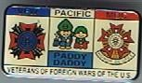

OBJECTIVE: The Grand of Pacific invites you to become a member of the Paddy Daddy Program established in 1994 to benefit the VFW National Home at Eaton Rapids, Michigan.
MISSION: Proceeds from this program are donated to support the VFW National Home for Children Special Projects from the Grand of Pacific Areas.
MEMBERSHIP: Application can be used for signing up Comrades, Cooties, Friends, Family, and yes, even your Pets can be signed up! Please fill out as many applications as you like for a very good cause.

Send the application to along with a check made out to "Ee CHI GAI Pup Tent # 2, in the amount of
USD $25.00, and your Certificate, Card and Pin will be mailed to you. If you have a question, please do not hesitate to Email George Beck at gbeck@vfw10223.org.

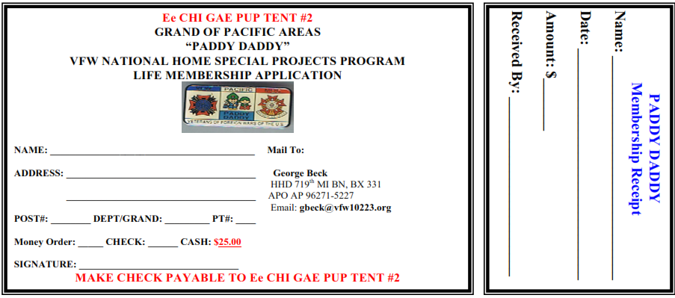

PENNSYLVANIA KEYSTONE KOPS PROGRAM
2018-2019

OBJECTIVE: The Grand of Pennsylvania invites you to become a member of the Keystone Kops Program established in 1984, which benefits the VFW National Home at Eaton Rapids, Michigan. MISSION: Proceeds from this program are donated to the VFW National Home to assist in the security of the Home and grounds.
MEMBERSHIP:
1. Membership may be obtained in the Grand of Pennsylvania’s Keystone Kops with the donation of the indicated amounts for each rank: Patrolman - $20.00; Sergeant - $40.00; Lieutenant - $60.00; Captain -
$80.00; Chief - $100.00; and Commissioner - $120.00.
2. Higher rank may be obtained at any time by paying a “Bribe” equal to the difference in cost between current and new rank and returning the old badge. Please add $3.00 for postage and handling.
3. Make your check or money order payable to: Keystone Kops and mail to: James B. Miller, Grand of Pennsylvania Keystone Kops chairman, P.O. Box 102 Mill Run, PA 15464. Please be sure to include your mailing address with ZIP code, VFW Post Number, and Pup Tent Number.

TEXAS HORNY TOAD PROGRAM 2018-2019
OBJECTIVE: The Grand of Texas invites you to become a member of the Horny Toad Program which benefits the VFW National Home for Children at Eaton Rapids, MI.
MISSION: Proceeds from this program are used to purchase vehicles for the VFW National Home for
Children at Eaton Rapids, MI. During the past 35 years, we have purchased twenty-seven vehicles for the
Home ranging from pick-up trucks, vans and station wagons.
PROGRAM INFORMATION/MEMBERSHIP:
- Annual Horny Toad membership is $1.00 per year. Annual members should remit $1.00 dues on a calendar year basis.
2. Life Horny Toad Program membership is $10.00 - payable only once.
3. Horny Toad Pins and other Horny Toad jewelry are available through the annual Horny Toad Chairman “Shorty” Lyons. Send your check or money order for what jewelry you want with check or money order made out to: Grand of Texas MOC and (ear mark it to the Horny Toad Program).
4. Send your check or money order for either $1.00 annually or $10.00 life membership, along with your complete address, your VFW Post number and/or Pup Tent number to individual program chairman listed below
5. Each member will be issued a distinctive numbered membership card and certificate listing his or her name. Also you can sign anyone up to be a Horny Toad member (Life or annual).
6. Grand Horny Toad Chairmen and contact information listed below.

Richard L. Kennedy, Grand Life Horny Toad Chairman7766 Grassbur Road Bryan, TX. 77808
Telephone (Home): 979-589-3137 Fax: 915-692-8244 E-mail: hornytoad1@lotcs.org
Terrance “Shorty” Lyons, Annual Horny Toad Chairman 5274 Belton Street Abilene, TX 79605
Telephone: (Home) 325-692-7254 (Cell): 325-668-4349 email: hornytoad1@suddenlink.net

THE BLUE GUARD PROGRAM
2018-2019

At the 79th Supreme Scratch, the Great Blue Louse invited the Cooties to join his Blue Louse Guard. Some of you joined and we hope all or more will join us. All the funds raised from the program will be set aside to a Special Fund to support the MOC-MOCA House at National Home.

The Blue Guard Program works as follows:
• Step 1: To become a Blue Guard you must join at this step and must serve one (1) year. You must pay a
$5.00 entry fee plus $1.00 annual dues. You may wear a Private stripe that cost $2.00. So the total cost for
Step one is $8.00.
• Step 2: You pay $10.00 plus $1.00 dues to earn a Sergeant stripe (if your dues are not sent in by 31 August each year, you have to start over at Step 1). You must have served one year as a Private. The Pin is $2.00. So the total cost for Step two is $13.00.
• Step 3: You pay $15.00 plus $1.00 dues to earn a Master Sergeant stripe. You must have served one year as a Sergeant. The Pin is $2.00. So the total cost for Step three is $18.00.
• Step 4: You pay $20.00 plus $1.00 dues to earn a Lieutenant bar. You must have served one year as a master Sergeant. The Bar is $2.00. So the total cost for Step four is $23.00.
• Step 5 and Step 6 are reserved for future ranks.

Fred Garcia is the Chairman for The Blue Guard Program, PSC, 909 East Constitution, Victoria, TX
77901. Telephone: 361-582-4359. E-mail: fgcootiepsc@att.net

Remember: On 31 August of each year you may up-grade or send in your $1.00 dues to remain in good standing!
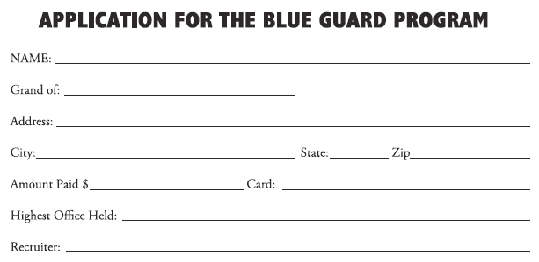

THE BLUE ANGEL PROGRAM
2018-2019

At the 79th Supreme Scratch, the Great Blue Louse invited the Lady Bugs to join his Blue Louse Guard.
Some of joined and we hope all or more will join us. I felt that the Blue Guard was not proper for our Auxiliary members. I started the Blue Angels to the house of the Great Blue Louse.
All the funds raised from the program will be set aside to a Special Fund to support the MOC-MOCA House at National Home.

The Blue Angel Program Works as Follows:
• Step 1: To become a Blue Angel any Auxiliary member may join at this step and must serve one (1) year. You must pay a $5.00 entry fee plus $1.00 annual dues. You may wear a blue star (“reaching for the Stars). The pin is $2.50.
• Step 2: You must pay $10.00 plus $1.00 dues. You will then earn your wings. You must have served one year as a blue star. The pin is $2.50.
• Step 3: You must pay $15.00 plus $1.00 dues. You will then earn your own cloud. You must have served one year as blue star. The pin is $2.50.
• Step 4: You pay $20.00 plus $1.00 dues. You will then earn your halo. You must have served one year
each as a blue star with wings and with your own cloud. The pin is $2.50
• Step 5 and 6 are reserved future ranks.

Fred Garcia is the Chairman for The Blue Angel Program, PSC, 909 East Constitution, Victoria, TX
77901. Telephone: 361-582-4359. E-mail: fgcootiepsc@att.net.

Remember: On 31 August of each year you may up-grade or send in your $1.00 dues to remain in good standing!
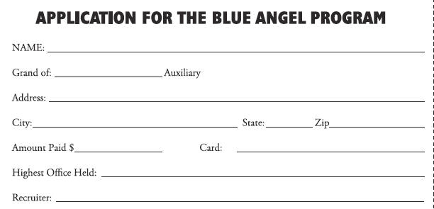

6th OREGON TRAIL PROGRAM 2018-2019

The Military Order of the Cootie of the United States Grand of Oregon is proud to introduce to the
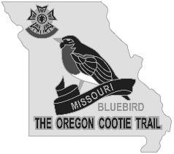

Cootie Nation and MOCA members everywhere, its latest
fundraising project to benefit veterans in need and

The National VFW Children's Home

"The Oregon Cootie Trail" Project
To become a member costs just $20

Pins of states that evolved out of the Oregon Territory or were involved with the original Oregon Trail are available for just $5 each. A membership package consisting of all 8 pins, a membership pin,
and a Certificate of Membership can also be purchased by mail.

Send a check for $63.50 (includes S.&H.) made out to: Grand of Oregon and mail to: Dennis Marsh, TO.C.T Chairman, P.O. Box 212, Florence, OR 97439

Be One of the First to Become an Oregon Cootie Trailblazer!

8th “MICHIGAN NITPICKERS”
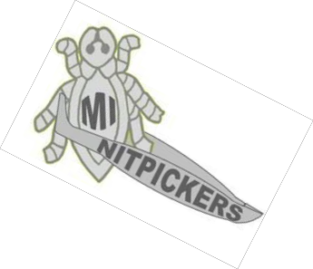

PROGRAM 2018-2019

OBJECTIVE: The Grand of Michigan invites you to become a member of the “Michigan Nitpickers”.

MISSION: Proceeds to the Grand of Michigan to help with all programs we are involved in to include possible donations to the VFW National Home for Cootie Christmas or our Support for the Children of the National Home Cedar Point Trip and Veterans Hospital Work. The Grand of Michigan chooses how the proceeds will be used.
MEMBERSHIP: To become an “ANNUAL MEMBER” (Silver) submit a donation of $10 plus $3 shipping. Or to become a “LIFE Member” (Gold) submit a donation of $30 plus $3 shipping. You will receive a card and Nitpicker Pin in Gold or Silver based on your donation. (No need for shipping if purchased from a Grand of Michigan representative on location.) SUBMIT TO: Make your check or money order payable to: MOC Grand of Michigan and mail to Chairman PGC Bob Routhier, Jr. P.O. Box
117, Clio, MI 48420.Telephone: 810-730-2233. Please be sure to include your mailing address with ZIP code, and include VFW Post and PT Number if applicable. Write in the memo Nitpicker, Annual or Life. The Grand of Michigan wishes to “Thank You” for your support

MICHIGAN NITPICKERS MEMBERSHIP APPLICATION NITPICKING is the act of removing nits: the eggs of lice. A NITPICKER is a Critic – To be concerned with or find fault with insignificant details. NITPICKER Synonyms: backseat driver, blamer,
complainant, criticizer, disapprover, disputer, doubter, faultfinder, mud-slinger, nagger and quibbler.

Name: Address: City: State: Zip:_ _ Telephone: Post Name / Number:
Pup Tent Name/Number:

Membership Type: | Annual Member (Silver) | $10.00 | Plus $3.00 Shipping
 | Life Member (Gold) | $30.00 | Plus $3.00 Shipping

Make your check or money order payable to: MOC Grand of Michigan and mail to: Chairman PGC Bob Routhier Jr., P.O. Box 117, Clio, MI 48420
Upon approval of membership application and payment, your Pin Badge and Card will be sent or given to you.

MOC HOSPITALIER KNIGHTS PROGRAM 2018-2019

The MOC has issued a special medal as a fund raiser for the organization. During the Crusades the first knights to enter the Holy Lands opened a hospital. They were named Hospitalier Knights. Later the Knights moved to the Island of Malta. They were than named Knights of Malta. Thus the Cross of Malta was formed by placing four lance heads together.

The Cross of Malta was adopted as the official logo of the VFW. Since the MOC is the Honor Degree of the VFW and since the MOC is the order that services the hospitals and cares for veterans and their families, it is only fitting that the medal be named “HOSPITALIER KNIGHT.” This medal comes in Bronze ($25.00), Silver ($50.00) and Gold ($75.00). The application is attached with this program.
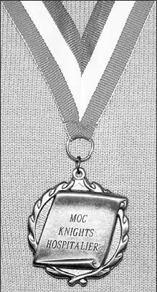

SUPREME HOSPITALIER KNIGHT ORDER FOR MEDAL

Name: Address: City: State: Zip:

Type of Medal:
BRONZE ($25.00) SILVER($50.00)
GOLD ($75.00)

Prices include all shipping and handling.
Please make your checks payable to: MOC Supreme Headquarters And mail to:
604 Braddock Ave. Turtle Creek, PA 15145

59th MARYLAND VFW NATIONAL HOME HONORARY FIRE DEPARTMENT 2018-2019

OBJECTIVE: The Grand of Maryland invites you to become a part of the world’s most unusual Fire Department (est. 29 April 1956) that is the only Fire Department in which you can buy your promotion legitimately.

MISSION: The money received in support of the Grand of Maryland Honorary Fire Department Program is presented each year to the VFW National Home, Eaton Rapids, MI.

MEMBERSHIP:
1. Membership may be obtained in the Grand of Maryland Honorary Fire Department with the Donation of the indicated amounts for each rank: Fireman - $56.00; Lieutenant - $66.00;
Captain - $71.00; Deputy Chief - $76.00; Chief- $81.00; and Commissioner - $106.00.
2. Make check or money order (no cash please) payable to: Grand Pup Tent of Maryland, and mail to
Larry Reid, 8806 Jenna Court, Lanham, MD 20706. Telephone: 301-577-1830. Email: Icreid@verizon.net. Be sure to include your name, address, city, state, and ZIP code, VFW Post Number, and Pup Tent Number.
3. There are no further dues or assessments. All proceeds go the VFW National Home, Eaton Rapids, MI.
4. Higher rank may be obtained at any time by paying the difference in cost and returning the former rank badge to the Chairman.

Note: Prices include $ 6.00 Shipping and handling Fee. (Sent Certified)

APPLICATION FOR MEMBERSHIP IN THE HONORARY
FIRE DEPARTMENT OF THE NATIONAL HOME

Name:
Address:
City: State: Zip:
VFW Post Number: ____________ Pup Tent Name: ________________________
Grand Pup Tent Number:

Make your check or money order (NO CASH PLEASE) payable to:
MOC Grand of Maryland,
and mail to: Larry Reid, 8806 Jenna Court, Lanham, MD 20706

PAST SUPREME COMMANDERS

SCRATCH YEAR LOCATION COMMANDER SCRATCH YEAR LOCATION COMMANDER
1920 Washington, DC Organizational
1st | 1920 | New York | Frederic C. Madden * | 51st | 1970 | Miami Beach | Dr. Frank O. Brasch*
2nd | 1921 | Detroit | Benjamin Gambill * | 52nd | 1971 | Dallas | Samuel R. Frutoso*
3rd | 1922 | Seattle | William F. Eighmey * | 53rd | 1972 | Minneapolis | Randy Lofgren*
4th | 1923 | Norfolk | F. Willard Kime* | 54th | 1973 | New Orleans | Owen W. Ball*
5th | 1924 | Atlantic City | F. Willard Kime* | 55th | 1974 | Chicago | Jerry Bloir*
6th | 1925 | Tulsa | Thomas. J. Nottingham* | 56th | 1975 | Los Angeles | George Jeschke*
7th | 1926 | El Paso | Robert E. Lee Murphy* | 57th | 1976 | New York | Mark A Farrell*
8th | 1927 | Providence | Val N. Brandon* | 58th | 1977 | Bloomington | John Sparks*
9th | 1928 | Louisville | Malachi F. Healy* | 59th | 1978 | Dallas | William Frey*
10th | 1929 | St. Paul | Edward H. Giguere* | 60th | 1979 | New Orleans | Frederick Kauﬀman *
11th | 1930 | Baltimore | Oscar J. Stearns, Jr.* | 61st | 1980 | Chicago | Eugene D. Thomas, Jr.
12th | 1931 | Kansas City | Charles F. Wetter* | 62nd | 1981 | Philadelphia | Lionel Fontaine*
13th | 1932 | Sacramento | Walter C. Winters* | 63rd | 1982 | Los Angeles | William E. Bryce
14th | 1933 | Milwaukee | Thomas C. Ryan* | 64th | 1983 | New Orleans | Arthur G. Selbo*
15th | 1934 | Louisville | George T. Dougherty* | 65th | 1984 | Chicago | Robert Graber*
16th | 1935 | New Orleans | Victor B. Galloway* | 66th | 1985 | Dallas | Bobbie Alton Birdett*
17th | 1936 | Denver | William J. Crehan* | 67th | 1986 | St. Paul | Eugene E. Calloway *
18th | 1937 | Buﬀalo | Thomas McBride* | 68th | 1987 | New Orleans | James H. Patterson *
19th | 1938 | Columbus | Carl C. Gibson* | 69th | 1988 | Chicago | Albert S. Thomas, Jr.
20th | 1939 | Boston | Patrick H. Houle* | 70th | 1989 | Las Vegas | Robert M. Cortright *
21st | 1940 | Los Angeles | William M. Harper* | 71st | 1990 | Baltimore | Thomas J. Atkins*
22nd | 1941 | Philadelphia | Ashley Beck* | 72nd | 1991 | New Orleans | Myron H. Rowe *
23rd | 1942 | Cincinnati | Frank Topash | 73rd | 1992 | Indianapolis | Donald V. Nettler *
24th | 1943 | New York | Daniel A. Tarantola* | 74th | 1993 | Dallas | John E. Hamilton
25th | 1944 | Chicago | Otto Steinberger* | 75th | 1994 | Las Vegas | Glen Maroney *
26th | 1945 | Chicago | Austin A. Flanagan* | 76th | 1995 | Phoenix | J.F. “Jack” Holleran *
27th | 1946 | Boston | Vincent C. Schaaf* | 77th | 1996 | Louisville | Gary Strauss *
28th | 1947 | Cleveland | Benjamin F. Griﬀey* | 78th | 1997 | Salt Lake City | Charles D. Short
29th | 1948 | St Louis | Richard E. Hodges* | 79th | 1998 | San Antonio | Larry Alexander
30th | 1949 | Miami Beach | A. Thomas Wheaton* | 80th | 1999 | Kansas City | Stephen H. Wheeler
31st | 1950 | Chicago | Newell Warner* | 81st | 2000 | Milwaukee | C. Marty Ellingwood
32nd | 1951 | New York | Percy W. Graves* | 82nd | 2001 | Milwaukee | Ken Cole
33rd | 1952 | Los Angeles | W. J. Gow* | 83rd | 2002 | Nashville | H. Steve Mason
34th | 1953 | Milwaukee | Ernest H. Moore* | 84th | 2003 | San Antonio | Fernando “Fred” Garcia
35th | 1954 | Philadelphia | William Wark* | 85th | 2004 | Cincinnati | Joseph “Rollin’ Joe” Velasquez
36th | 1955 | Boston | Raymond Burke* | 86th | 2005 | Salt Lake City | Thomas Tweet
37th | 1956 | Dallas | Raymond F. Nichols* | 87th | 2006 | Reno | Terrance “Shorty” Lyons
38th | 1957 | Miami Beach | Ervin F. Rothenbuhler* | 88th | 2007 | Kansas City | Raymond “Ray” Fern*
39th | 1958 | New York | George E. Hunt* | 89th | 2008 | Orlando | Ralph Corno
40th | 1959 | Los Angeles | Joseph E. Jacques* | 90th | 2009 | Phoenix | Johnny L. Howard
41st | 1960 | Detroit | Charles W. Briner* | 91st | 2010 | Indianapolis | C. Maurice Theriac
42nd | 1961 | Miami Beach | Angus McNaught* | 92nd | 2011 | San Antonio | George Dennis *
43rd | 1962 | Minneapolis | John W. Burnett* | 93rd | 2012 | Reno | Joseph T. McCullough
44th | 1963 | Seattle | Dr. Vernon G. Olson* | 94th | 2013 | Louisville | Gerald L. Constable
45th | 1964 | Cleveland | Fred L.Finch, Sr.* | 95th | 2014 | St Louis | Mark Newman
46th | 1965 | Chicago | Donald Ferguson * | 96th | 2015 | Pittsburg | Dave Wimmer *
47th | 1966 | New York | Patrick McCaulla * | 97th | 2016 | Charlotte | Donald Lynch
48th | 1967 | New Orleans | Darwin Cochran* | 98th | 2017 | New Orleans | James D. Malott
49th | 1968 | Detroit | George E. Jalbert* | 99th | 2018 | Kansas City | Dan Kramer
50th | 1969 | Philadelphia | Jean R. Brelsford* | 100 th | 2019 | Orlando
* Deceased

SCHEDULE OF EVENTS 2018 - 2019

MOC EVENT | LOCATION | DATE
99th Supreme Scratch | Kansas City, MO | 26 - 29 July 2018
Sharing & Caring | Pittsburgh, PA | 8 Sept 2018
84th Tomb Trek | Arlington, VA | 2-4 Nov 2018
President Potter  Homecoming | TBA | TBA
90th Grand of Michigan  Cootie Christmas | VFW National Home,  Eaton Rapids, MI | 1 Dec 2018
Commander Soltesz  Homecoming | Arlington, VA | 3 Nov 2018
36th Grand of Ohio  Easter Treat | VFW National Home,  Eaton Rapids, MI | 12-14 April 2019
100th Supreme Scratch | Orlando, FL | 24 - 28 July 2018

VFW EVENT | LOCATION | DATE
119th VFW  National Convention | Kansas City, MO | 21 - 25 July 2018
National Council of  Administration | Kansas City, MO | 25-26 Aug 2018
National President  Café & Celebration | Hanover, MD | 6-9 Sept 2018
Commanders in Chief  Homecoming | Albuquerque, NM | 20-23 Sept 2018
Southern Conference | Louisville, KY | 18-21 Oct 2018
Big Ten Conference | St. Louis, MO | 19-21 Oct 2018
Western Conference | Vancouver, WA | 1-4 Nov 2018
Eastern Conference | Framingham, MA | 16-18 Nov 2018
VFW Legislative Conference | Washington, DC | 3-7 Mar 2019
120th VFW  National Convention | Orlando, FL | 20 - 24 July 2019

